**System Planning and Process**

Lauren Alexandra

Colorado State University Global

CSC 501: Management for the Computer Science Professional

Dr. Charles Lively

June 2, 2021

**Introduction**

Project

include references 4 and 5 in intro.

**Four**

Ashfaq, A., Muhammad, B., Khalid, L. & Zainab. (2021). A Study of Project Management Processes for Sustainable and Successful Projects in Software Industry: Expectations vs. Perceptions of Managers. *Journal of Accounting and Finance in Emerging Economies, 7*(1).

The **project** managers who are familiar with PMPs are therefore needed for the proper implementation of these **processes**, which will lead to sustainable and successful software **projects**.

**Five**

Felician, A. (2011). Management of Software Development Projects. *Oeconomics of Knowledge, 3*(2), 10-18.

Any major software development starts with the Initiating **process** group. Once the charter document is approved, the Planning and then to the Executing stages will follow. Monitoring and Controlling is measuring the potential performance deviation of the **project** in terms of schedule and costs and performs the related Integrated Change Control activities. At the end, during the Closing, the program/**project** manager will check the entire work is completed and the objectives are met.

a description of the project and all the project's associated processes

discuss the details associated with planning, inception, project lifecycle, and closure

need to review notes for each of these phases specifically and make sure they are addressed directly

try to provide a little more detail in your introduction

**System Selection**

The system I selected is a project management API utilizing Python and Blockchain technology. The API will support a management board in which project activities are grouped by phases (Initiation, Planning, Execution, Launch, and Closure). Each activity can be granted a status, timeline, cost, and cost type.

**Lifecycle**

**Figure 1**

*Lifecycle*

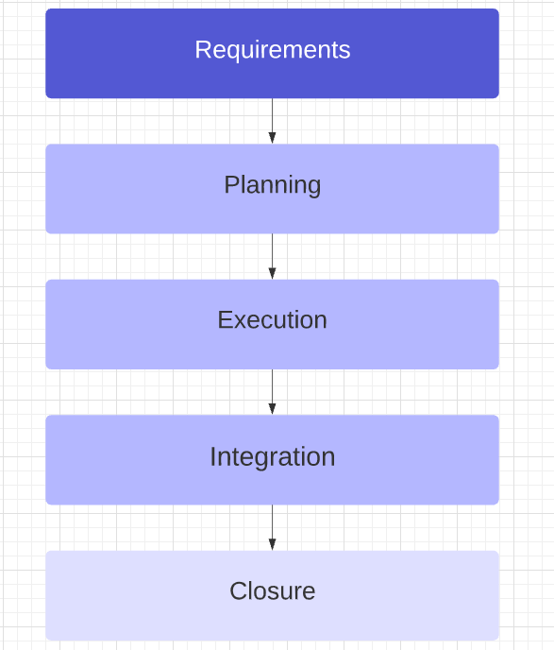

The product lifecycle (see Figure 1) will be composed of five phases. In the requirements phase, the client and project team will convene and the product will be defined (Dalcher, 2014). The planning phase forms the project foundation, isolating the schedule, acquiring resources, and establishing workflows. Approval is required from stakeholders before advancing to the next phase. During execution, the implementation of product components will occur and as milestones are met or issues encountered, progress will be communicated as appropriate to stakeholders. Subsequently in the integration phase, the product will be assembled and thoroughly tested for any exceptions or failures. Lastly, during closure the project manager will meet with assurance staff and final reports will be generated in addition to other documentation for knowledge transfer.

**Environment Variables, Scope Processes, and Organizational Systems**

**Figure 2**

*Plan Inputs*

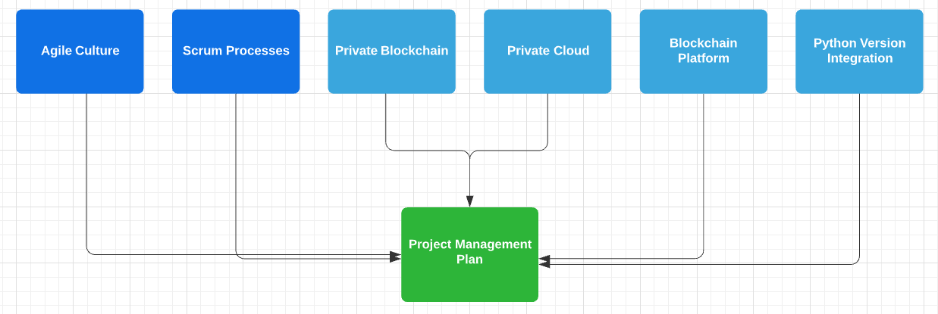

The Project Management API project planning will need to account for environment variables, scope processes, and organizational systems (see Figure 2). The project will subscribe to an iterative development approach, Agile methodology, specifically using the Scrum framework. Scrum actively limits scope creep and reduces the overall project risk by guaranteeing at least some of the project’s most in demand deliverables (Scrum Alliance, n.d.).

Given that Python 2 is no longer supported as of 2020, any software created or incorporated by third party libraries should use Python 3 (Yegulalp, 2020). Ensuring that any dependencies are Python 3 compatible is crucial.

A blockchain-as-a-service platform should be considered to build and operate a blockchain network (IBM, 2021). The platform would allow engineers to deploy blockchain components to development through production environments. Further, the platform could provide the appropriate security needed for an enterprise blockchain API.

A private blockchain network would allow the client to control who can participate, enact a consensus protocol and manage a shared ledger. The network can be hosted on a private cloud for additional security.

**Project Design and Outline**

**Figure 3**

*Project Management API*

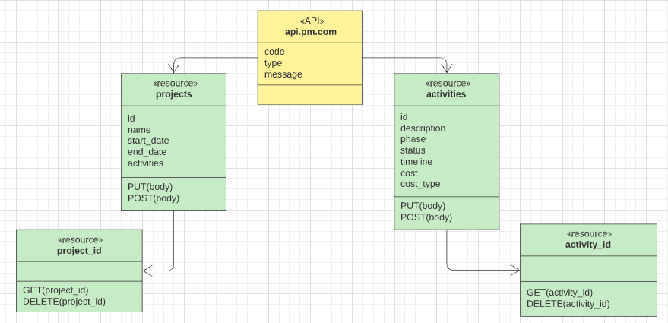

*Note*. The diagram models a Python API. The API can support a management board in which project activities are grouped by phases (Initiation, Planning, Execution, Launch, and Closure).

**Scope**

The project will encompass a project management API built with Python that interfaces with a blockchain API which stores data on a private business ledger. The separation of concerns allows the API to address the problem of project management and allocates the responsibility of blockchain to an enterprise blockchain as a service solution. The solution will be employed for creating and hosting a blockchain business network.

The API is a RESTful API using JSON on the HTTP protocol and consists of three resource archetypes: docroot, resource, and collection (see Figure 3). The docroot or entry point will be <https://api.pm.com>. A resource can be viewed as an object instance that can include field values and resource links. Individual resources like project or activity can be accessed by their ID, for instance, *activities/1*. A project resource contains an ID, name, start date and end date, and a resource link, activities. An activity resource maintains an ID, description, phase, status, timeline, cost, and cost type. Resources are the base archetype for collections. A collection is a server-managed directory of resources, e.g. <https://api.pm.com/projects/1/activities>. Lastly, every response generated from accessing a resource will be passed as a parameter to a blockchain API.

Blockchain will aid in producing an immutable record of project management events using distributed ledger technology (Norris, 2019). The IBM Blockchain Platform gives engineers the ability to make a Hyperledger Fabric network and deploy it on an IBM Kubernetes service, in addition to creating smart contracts on the network (Cuomo et al., 2018). Hyperledger Fabric is a ledger that maintains both the current value of all objects or world state on the ledger and a blockchain that documents all transactions that produced the present state (Hyperledger, 2020). A smart contract is code running on a blockchain that allows engineers to designate business processes and data shared on a blockchain business network. In the permissioned network, the team using the project management API and the client benefiting from the corresponding project will share accurate data thereby establishing greater trust. The IBM Blockchain Platform extension will be utilized in creating smart contracts and connecting to Hyperledger Fabric environments (Microsoft, n.d.).

Once a smart contract is constructed and deployed to a private business network, the contract can be retrieved from the network and stored as a variable (see Figure 4). Then throughout an application, after a project management API call, the API response can be passed as a value to submit a transaction. This call will send the response to the ledger to record the project event.

**Figure 4**

*Chaincode*

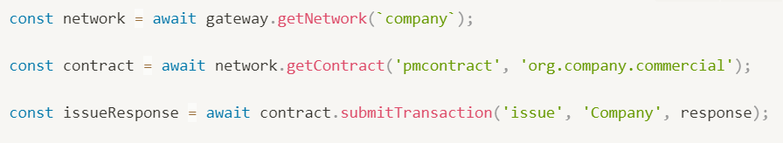

**Estimates and Changes**

The API may be modified to include new attributes and additional resources (Martinsuo & Vuorinen, 2019). Moreover, stakeholders may request a change in where the network is hosted. The project will use an IBM cloud service, but the network can live on AWS or Microsoft Azure or another cloud vendor. Fortunately, IBM’s blockchain platform can run in any infrastructure. As for timeline, we are estimating one sprint for inception, eight sprints for delivery, and two sprints for maintenance.

**Design Methodology**

**Figure 5**

*Integration Tasks*

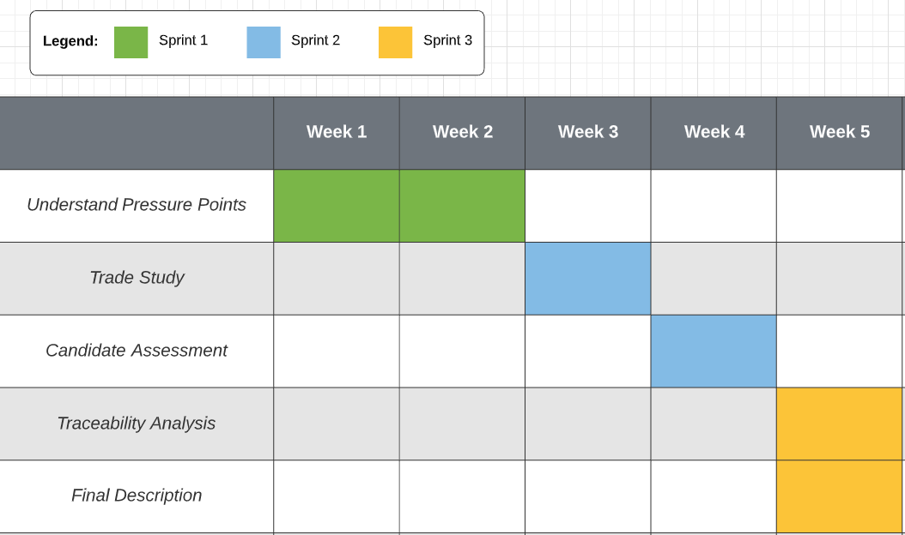

The project management API project demands the team decide not only on the requirements but also how the requirements will be implemented. An algorithm for creating the design is depicted as follows: understand the pressure points; conduct a trade study; assess the selected candidate; affirm design validity; provide design description (see Figure 5). First, by knowing the user mission the true design drivers can be identified (Stretton, 2015). This is critical because the customer may be focusing on a detail not impacting their problem.

A trade study is a process that produces candidate designs and identifies the rank of each candidate. The process enables us to find the right balance of features and choose the right solution. The project’s study needs to effectively measure performance.

Operational performance measures and technical performance measures can measure the fit of each candidate. Both metrics are necessary because increased performance in one area does not always guarantee performance in the other. Moreover, the study is responsible for creating and evaluating candidates for selection.

The design selected will be evaluated across four axes. Design performance and capacity will be analyzed through modeling and benchmarking. API stability will be controlled through input type guards and error handling. To account for flawed implementation, the API must be built with a design margin in mind. Each API component should maintain a single responsibility; this allows engineers to identify errors sooner. This approach is part of circumventing design pitfalls. Engineers should implement the API with the intention of avoiding unwanted dynamic behavior.

The engineers can confirm for themselves and the stakeholders that all requirements have been accomplished through a traceability analysis. Every requirement must be mapped within the API. Lastly, the final design will be further elaborated and explained, and will provide the engineering team direction in generating user stories.

**Risk Assessment**

**Figure 6**

*Project Risk Matrix*

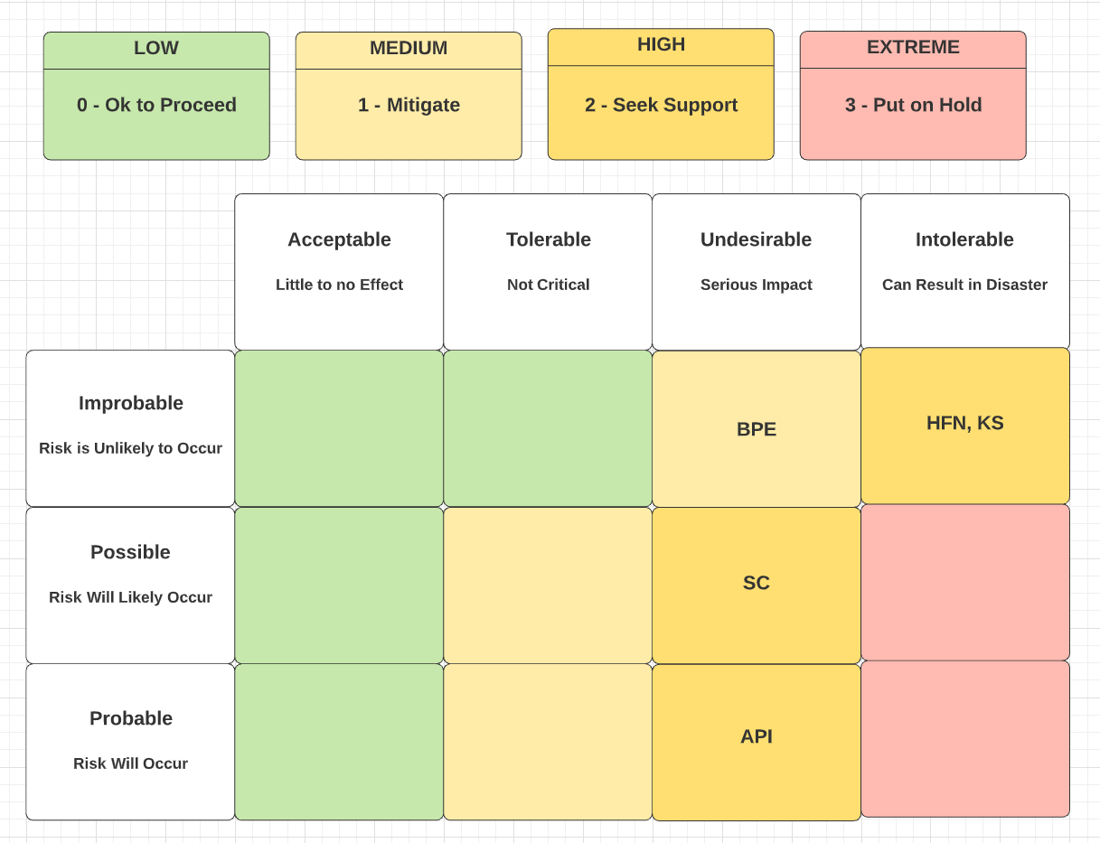

An analysis of how potential problems may occur prepares the team to mitigate risks as appropriate during execution (Ikhtiar & Indra, 2016). A risk matrix (see Figure 6) highlights both the likelihood and severity of the project risks.

API risk: API Bugs. Flaws within the API are to be expected but with thorough unit and integration testing in addition to defensive programming practices, the probable and undesirable risk can be reduced. Engineers can program defensively by first accepting that errors will arise and then writing code to combat them when they do happen. Also implementing pre- and post-conditions defends against unsafe inputs and outputs. Moreover every function should exhibit a single responsibility and be paired with tests validating the declared responsibility. Thereafter once the smart contract is built, integration testing should occur.

SC risk: Incorrectly written smart contract. Developers without previous exposure to blockchain smart contracts may codify flaws in the contract possibly leading to serious impact. However IBM does provide documentation for creating smart contract projects to assist novice blockchain developers. The IBM Blockchain Platform VS Code extension also comes with smart contract template types. A default contract illustrates how to perform CRUD operations to the ledger shared by the blockchain business network members. Additionally there is a private data contract template that showcases CRUD operations to a collection (for a single network member).

HFN, BPE, and KS risks: Unknown Issues in the Hyperledger Fabric Network, IBM Blockchain Platform extension, and IBM Kubernetes service. The likelihood of unknown issues severely derailing the project is improbable. The software is frequently monitored for issues and IBM has the capacity to address them and inform developers of workarounds and patches. Yet, if issues were to occur they could slow down or completely block project execution and delivery. If the Kubernetes service fails to remain a viable solution, another cloud provider can be selected to host the blockchain network.

**Stakeholders**

**Figure 7**

*Project Stakeholder Management*

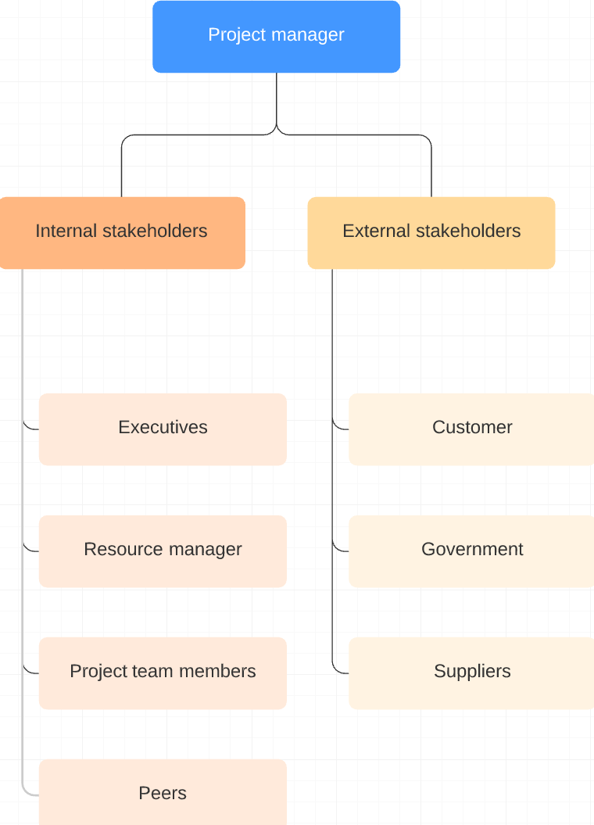

The stakeholders on this project require specific management strategies applied to their roles. Executives such as the company president, vice-presidents, directors, and division managers are responsible for directing company strategy and approving project plans. An appropriate reporting methodology should be employed to inform executive management on project milestones and risks.

The project may need the team to pull resources from surrounding teams. Building strong relationships with other managers in charge of resources is crucial to orchestrating the necessary inflow of project staff.

Project team members take direction from the project manager as they accomplish their committed tasks. Some team members may be juggling other responsibilities at the time of the project and also may conflict with management’s leadership style. By keeping engagement high throughout project planning and execution as well as meeting with team members one-on-one to hear feedback and concerns, members with multiple priorities can be better led.

Peers are individuals within the company who have a vested interest in the project’s outcome and may or may not be on the team. They do not carry the leadership responsibility for project success or failure. Personality or technical conflicts may arise from peers. Review meetings should be conducted often and management should ask directly for full support from peers.

As for external stakeholders, the customer represents various businesses that may use the API. The businesses themselves are likely overseen by government regulators and require project activities to be documented by the API in specific ways, adhering to legal obligations. If customizations are requested by businesses, a later version of the API would need to address them. Lastly, the project relies on suppliers of blockchain and cloud technology to support the API. If issues arise that can not be resolved within their platforms, then the project will have to utilize other providers.

**Conclusion**

Conclude

try to provide a little more insight with your conclusion. it should provide a high-level overview of your work but still be concise

**References**

Cuomo, J., Cocco, S., & Singh, G. (2018, March 18). *Develop, govern, and operate your*

*business network with the IBM Blockchain Platform*. IBM.

[https://developer.ibm.com/tutorials/cl-ibm-blockchain-platform-develop-govern-o](https://developer.ibm.com/tutorials/cl-ibm-blockchain-platform-develop-govern-operate-your-business-network/)

[erate-your-business-network/](https://developer.ibm.com/tutorials/cl-ibm-blockchain-platform-develop-govern-operate-your-business-network/)

Dalcher, D. (2014). Who needs project requirements? *PM World Journal, 3*(4).

Hyperledger. (2020). *A Blockchain Platform for the Enterprise*. Hyperledger Fabric.

<https://hyperledger-fabric.readthedocs.io/en/release-2.1/index.html>

IBM. (2021, February 14). *Getting started with IBM Blockchain Platform*.

<https://cloud.ibm.com/docs/blockchain?topic=blockchain-get-started-ibp>

Ikhtiar, F. & Indra D. (2016). Risk Management Method In It Project: A Review.

*ComTech, 7*(3), 173-180.

Martinsuo, M. M. & Vuorinen, L. (2019). Lifecycle View of Managing Different Changes

in Projects. *International Journal of Managing Projects in Business, 12*(1),

120-143.

Microsoft. (n.d.) *IBM Blockchain Platform Extension for VS Code*. Microsoft.

[https://marketplace.visualstudio.com/items?itemName=IBMBlockchain.ibm-bloc](https://marketplace.visualstudio.com/items?itemName=IBMBlockchain.ibm-blockchain-platform)

[chain-platform](https://marketplace.visualstudio.com/items?itemName=IBMBlockchain.ibm-blockchain-platform)

Microsoft REST API Guidelines Working Group. (2016, July 19). *Microsoft REST API*

*Guidelines*. GitHub.

<https://github.com/microsoft/api-guidelines/blob/vNext/Guidelines.md>

Norris, T. (2019, June 5). *Using blockchain as a project management device*. IBM.

<https://www.ibm.com/blogs/blockchain/2019/06/using-blockchain-as-a-project-management-device/>

Project Management Institute. (2017). *A Guide to the Project Management Body of*

*Knowledge*. Project Management Institute.

Scrum Alliance. (n.d.) *The Agile Manifesto*.

<https://www.scrumalliance.org/resources/agile-manifesto>

Siegel, N. G. (2019). *Engineering Project Management.* John Wiley & Sons Ltd.

Stretton, A. (2015). Approaches to increasing Level 2: “Project” success. *PM World*

*Journal, 4*(3).

Yegulalp, S. (2020, April 22). *Python 2 EOL: How to survive the end of Python 2.*

<https://www.infoworld.com/article/3365221/python-2-end-of-life-how-to-survive-the-end-of-python-2.html>

Six SCHOLARLY references: need to include in paper above

**One X**

Stretton, A. (2015). Approaches to increasing Level 2: “Project” success. *PM World*

*Journal, 4*(3).

from Module 4:

**Two X**

Dalcher, D. (2014). Who needs project requirements? *PM World Journal, 3*(4).

from Module 1 opt 2 project lifecycle phases:

**Third X**

Martinsuo, M. M. & Vuorinen, L. (2019). Lifecycle View of Managing Different Changes

in Projects. *International Journal of Managing Projects in Business, 12*(1),

120-143.

**Four**

Ashfaq, A., Muhammad, B., Khalid, L. & Zainab. (2021). A Study of Project Management Processes for Sustainable and Successful Projects in Software Industry: Expectations vs. Perceptions of Managers. *Journal of Accounting and Finance in Emerging Economies, 7*(1).

The **project** managers who are familiar with PMPs are therefore needed for the proper implementation of these **processes**, which will lead to sustainable and successful software **projects**.

**Five**

Felician, A. (2011). Management of Software Development Projects. *Oeconomics of Knowledge, 3*(2), 10-18.

Any major software development starts with the Initiating **process** group. Once the charter document is approved, the Planning and then to the Executing stages will follow. Monitoring and Controlling is measuring the potential performance deviation of the **project** in terms of schedule and costs and performs the related Integrated Change Control activities. At the end, during the Closing, the program/**project** manager will check the entire work is completed and the objectives are met.

**Six X**

Ikhtiar, F. & Indra D. (2016). Risk Management Method In It Project: A Review. *ComTech, 7*(3), 173-180.